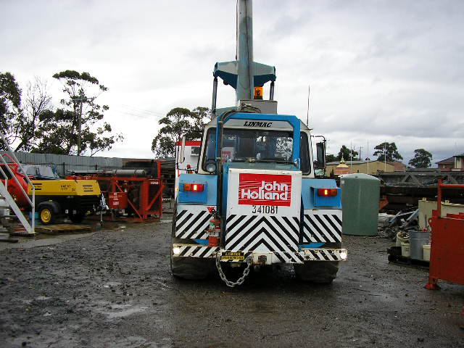 | Hazard Information Sheet
  Equipment: | Cranes
 | Equip Type: | Cranes - Diesel
 | Generic Description or  Specific Make / Model: | Cranes
 | Type: | Diesel
 | Other Details

Operator Requirements: | Operators must be trained and competent to use this equipment safely.
Purpose For Which This Equip Is Designed: | For use on firm stable ground capable of supporting the weight of the maximum load.

Hazards & Risks:
Control Measures:
Commissioning, Installation & Erection of Equip:  Failure to consult model specific operating instructions may mean operator is unfamiliar with machines functions and result in an accident. | Prior to using the machine, operator to refer to model specific operating instructions.
Failure to consult logbook and conduct “Operator Daily Safety Checks” may mean machine is being used in an unsafe condition. | Prior to using machine, operator to refer to logbook on machine and conduct “Operator Daily Safety Checks” as detailed.
Crushing (Squashing):  Unexpected movement of plant. | The chassis can drop down suddenly when past the point of balance causing a catapulting action, Therefore:  (i) When about to go over the point of balance and down a downward slope, or approaching the end of an upward slope (this includes driving up or down ramps), drive machine at creep speed with crane sufficiently retracted and lowered to cater for any sudden “lift’ or “drop”.  (ii) Ensure you allow sufficient “headroom” or clearance to cater for “sudden lifts”, especially when operating under structures, or near power lines or other elevated services etc.

Disclaimer: In fulfilment of its statutory obligations, (ARS) & John Holland has taken what it considers to be all reasonable precautions and exercised due diligence to ensure that it has provided all relevant information on the safe use of the plant. However, except as required by law and only to the extent so required, (ARS) & John Holland does not make any representation, warranty or undertaking, express or implied, as to, or accept any responsibility or liability for, the accuracy or completeness of, or any errors in or omissions from, this Hazard Information Sheet. Except as required by law and only to the extent so required, neither (ARS) & John Holland nor any of its respective directors, officers, agents, or employees shall in any way be liable directly or indirectly to any person or body for any loss or damages, costs or expenses whatever arising out of or in connection with the information contained in this Hazard Information Sheet. | Date: 19/06/06
Equipment: | Crane  Diesel

Hazards & Risks: | Control Measures:
Parts of the plant collapsing. | Ensure no personnel working under any part of crane, remember the golden rule “Do not walk or work under raised hydraulics”.
Someone being crushed when slewing, raising or lowering crane. | Keep personnel clear.
Body or limbs can be crushed if not kept clear of crane arm. | Operator awareness — do not allow any part of body through, under or between crane arm.
Being trapped between the plant and materials, or fixed structures. | Avoid congested work areas.
Driving into bystanders. | Ensure audible and visual alarms operating when equipment is in motion. Clearly define work area. Keep personnel clear.
Electrical:  Electrocution from overhead power lines. | Maintain at least 6m clearance from overhead power lines. Barricade off work areas. Insulate power lines. Remember the golden rule, “Look Up And Live” (before and during elevation).
Water near electrical equipment. | Use weatherproof equipment/fittings outside. If cleaning machine do not use pressurised water near control boxes or other electric / electronic components.
Entanglement:  Becoming entangled in moving parts. | Keep personnel clear. Barricade off/designate work area. Adopt appropriate dress (no loose clothing etc).
High Temperature or Fire:  Refuelling: When refuelling, sparks, flames, hot engine can ignite fuel. | Operator is responsible to shut down engine prior to refuelling. Refuel in a well ventilated area. Ensure that there are no naked flames in the area. DO NOT SMOKE. Avoid spilling fuel and collect any fuel run off.
Coming into contact with hot parts. | Keep clear of exhaust outlet.

Disclaimer: In fulfilment of its statutory obligations, (ARS) & John Holland has taken what it considers to be all reasonable precautions and exercised due diligence to ensure that it has provided all relevant information on the safe use of the plant. However, except as required by law and only to the extent so required, (ARS) & John Holland does not make any representation, warranty or undertaking, express or implied, as to, or accept any responsibility or liability for, the accuracy or completeness of, or any errors in or omissions from, this Hazard Information Sheet. Except as required by law and only to the extent so required, neither (ARS) & John Holland nor any of its respective directors, officers, agents, or employees shall in any way be liable directly or indirectly to any person or body for any loss or damages, costs or expenses whatever arising out of or in connection with the information contained in this Hazard Information Sheet. | Date: 19/06/06
Equipment: | Crane  Diesel

Hazards & Risks: | Control Measures:
Noise:  Exposure to noise. | Wear appropriate hearing protection.
Striking (Hitting):  Bystanders may be struck when equip is slewed or driven. | (i) Operator training and awareness. Ensure audible and visual alarms operating when equip travelling. Barricade off work areas.  (ii) Operator to check arrow plate of the machine to determine “forward” before engaging travel.
Suffocation:  Exposure to exhaust fumes, from other equipment in vicinity especially if sited in a confined space. | Operator/user responsible to operate the machine in a well ventilated area.

Disclaimer: In fulfilment of its statutory obligations, (ARS) & John Holland has taken what it considers to be all reasonable precautions and exercised due diligence to ensure that it has provided all relevant information on the safe use of the plant. However, except as required by law and only to the extent so required, (ARS) & John Holland does not make any representation, warranty or undertaking, express or implied, as to, or accept any responsibility or liability for, the accuracy or completeness of, or any errors in or omissions from, this Hazard Information Sheet. Except as required by law and only to the extent so required, neither (ARS) & John Holland nor any of its respective directors, officers, agents, or employees shall in any way be liable directly or indirectly to any person or body for any loss or damages, costs or expenses whatever arising out of or in connection with the information contained in this Hazard Information Sheet. | Date: 19/06/06

